Weekly Newsletter for week beginning ^{1st} July 2019
Statement to live by for next week: I try to be accepting of others

Attendance
The classes with the highest attendance this week were Year 5 and Year 6.
Year Group | Percentage Attendance
Year R | 91.3
Year 1 | 96.2
Year 2 | 95.3
Year 3 | 91.5
Year 4 | 94.0
Year 5 | 98.3
Year 6 | 98.3
95.5%
They achieved 98.3% attendance this week.
Well done Years 5 and 6!

100% Attendance
Letters will be going out shortly to our 100% attenders
in school this year. We have a special treat in store
for parents and pupils at lunchtime on Monday 22nd
July. Invitations will be sent out shortly with further
details of this.

Reception Class Assembly
Well done to our Reception class on Thursday for their wonderful class assembly. We really do have some talented children and it was lovely to see them singing, dancing and sharing what they have learnt this year. They certainly have all grown in the last year and I can see that they are ready to join Year 1 in September.
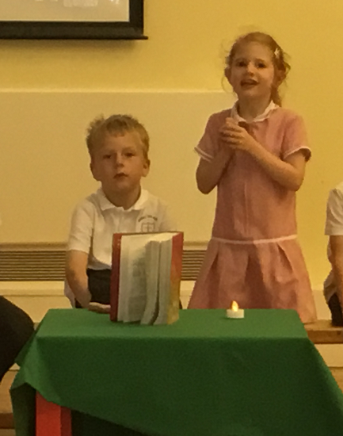
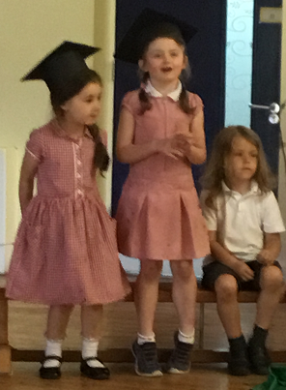

Summer Fair
Today we had our school Summer Fair. Thank you to all those who helped to set up and run stalls and organise the event. I would like to thank in particular Mrs Hartley and Mrs Sykes for all their organisation prior to the event and the teaching assistants and teachers in school who have volunteered their time and stayed behind this afternoon. Also thank you to the parents who have volunteered to support. We are always looking for new members to join the SOCK PTA group in order to continue with fundraising events to support your children in school. As you know this isn’t possible without your help and the more support we have, the more fundraising we can do.

Raffle Prizes
We would also like to thank the local companies in our area who generously donated some of the prizes for our raffle:
Leeds United, The Travellers Rest, Oxygen Free Jumping Trampolining, Lazer Zone and Monster Kidz
The winners of the prizes were:
Yellow 54, Yellow 2, Yellow 17, Yellow 30, Yellow 16, Yellow 26, Yellow 28, Yellow 94, Yellow 7, Yellow 34, Yellow 52, Yellow 3 and Yellow 23.
Do check you raffle tickets to see if you are a winner. The prizes can be collected from the main school office.

Year 5 and Year 6 production
The children in Year 5 and Year 6 will be performing their end of Year production next week on 10th July at 5:30pm and 11th July at 1:30pm. I have to say, from the singing I have heard in the school,I have no doubt that it will be a musical extravaganza!
A reminder that all pupils in Years 5 and 6 are expected to be at both performances, as everyone plays an important part in this end of year production. If you haven’t already got your tickets for the show, please do contact the school office.

Sporting News
Our netball team, who entered the final round for the Bishop’s Cup, played at Cardinal Heenan on Wednesday. We were all very proud of the team as they moved up to the next finals group this year. The competition was very tough and most of the teams were made up of Year 6 pupils so our Year 5 girls did exceptionally well.

New Year Reception pupils
We will be having our transition mornings for our pupils who will be joining Christ the King on Tuesday 16th July and Thursday 18th July between 9:30am and 11:30am. Mrs Hartley, Miss Riggs and Miss Elam will also be carrying out home visits in the week beginning 15th July. We are looking forward to our new Reception pupils starting and I know that all of the children in school will help them and make them feel very welcome.

Leeds Rhinos
Next week we are looking forward to a special visit from the Leeds Rhinos and a surprise guest visitor. The Leeds Rhinos have been working with our pupils in Year 1 and Year 2 who have been learning some new rugby sporting skills.

Miss Clark
(Headteacher)

Upcoming Dates
16.07.19 – 9:30am – 11:30am New Year R children transition morning
18.07.19 – 9:30am – 11:30am New Year R children and whole school transition morning
22.07.19 – 2:00pm Year 6 Leavers Assembly
23.07.19 - 9:00am Year 6 Leavers Mass
23.07.19 – School closes for the Summer break to pupils
24.07.19 – Training Day

