Weekly Newsletter for week beginning 3rd June 2019
Statement to Live by for next week: I understand the importance of peace.

Attendance
Year Group | Percentage Attendance
Year R | 94.1
Year 1 | 99
Year 2 | 91.4
Year 3 | 96.9
Year 4 | 92.1
Year 5 | 96.6
Year 6 | 99.6
95.5%
The highest attendance this week was 99.6% in Year 6.
We will be announcing our 100% pupils from last half
term in Celebration Assembly next week and they will
be entered into our raffle for a prize. We will also be
looking to invite parents and pupils to share in an
Italian pizza and ice-cream lunch with us at the end of
the term for those pupils who have had 100%
attendance for the whole year – what an achievement!

Phonics Screening Testing
Next week all of our Year 1 pupils will be completing their Phonics Screening Test. Miss Wright will be taking the children to complete this test. They are all familiar with it as they have completed a practice test already to minimise any anxiety. We ask that all parents ensure that their children are in school every day next week. The Phonics Screening Test is a statutory government test that we are required to complete with the pupils in Year 1 next week. In addition to this, any pupils in Year 2 who did not pass the test last year will be re-sitting this with Miss Wright again this year under the DFE guidelines.

Year 1 and Year 2 Trip to Ledston Estate
On Tuesday our children in Year 1 and 2 went on their class trip to Ledston Estate. The children all had a wonderful time completing a nature scavenger hunt, creating dens, finding out about how trees grow from seedlings and learning a little bit about woodland management. This work all supports the science topic that the children will be learning about this term on Living things and their habitats.
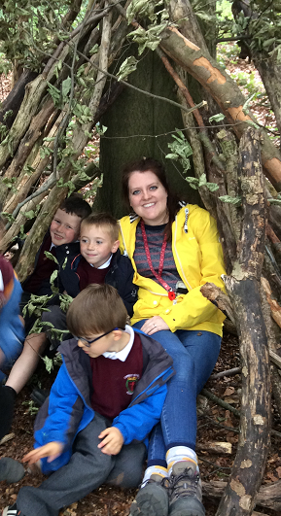
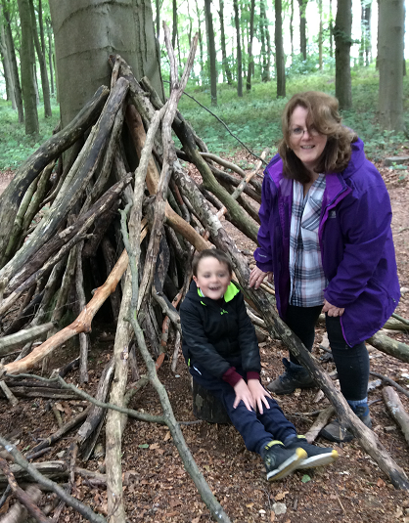

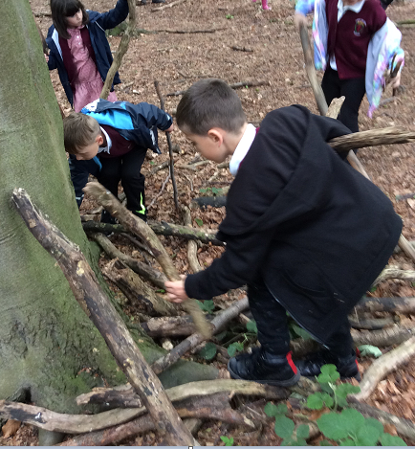
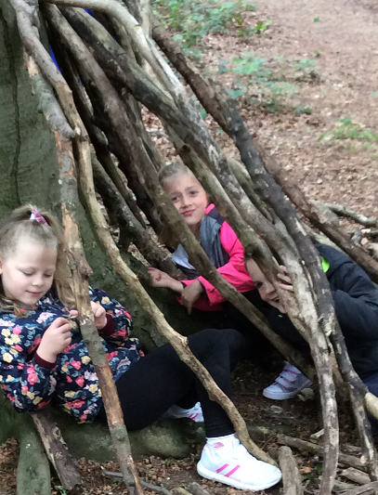

Training Days for 2019- 2020
The training days for next year will be sent out to parents alongside the school holiday dates next week. We will also be placing these on the school website. Please ensure that you are booking holidays outside of the term time for next academic year.

Kingswood Residential
Our pupils in Years 5 and 6 who took part on the Kingswood residential all had a fabulous time! I visited them after school on Thursday evening and we had a campfire where the children took part in singing and had the opportunity to share jokes with each other. I know that the children have all grown in confidence over the time that they were away and many of our children tested themselves with activities that were at first a little daunting for them. They worked brilliantly in their teams together to support each other. I was very proud to hear about all of their achievements. I would like to say a big thank you to Mrs Waide, Mrs Mitchell, Mrs Mason and Mr Davey for looking after all of the children during the time that they were away. As you know, these trips would not be able to go ahead without the support of our dedicated staff in school. We will be posting some of the photos on the school website from the trip and on the newsletter next week.

Year 5 and Year 6 pupils at Leeds West Activity Centre
This week our Year 5 and Year 6 pupils who did not attend the residential have also been putting their team work skills to the test today during a visit to the Leeds West Activity Centre. The children took part in orienteering activities, assault courses and other physical and team building activities. They have all clearly enjoyed their day. I think all of our Year 5 and 6 pupils will sleep well this weekend after a week of lots of physical activity keeping them fit and healthy.

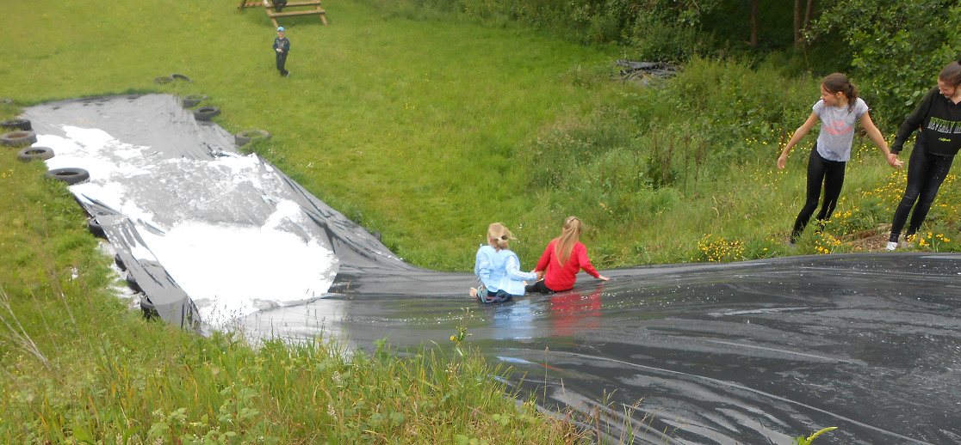
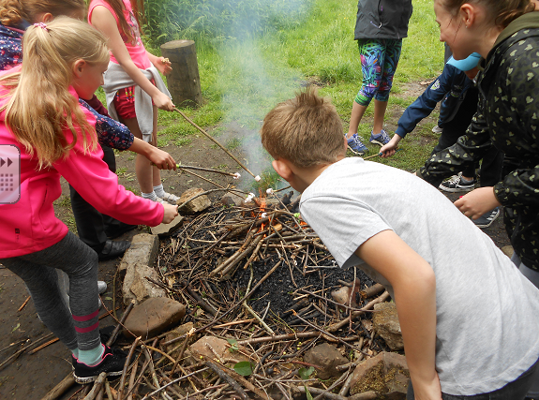

Summer Fair
On Tuesday we held a meeting for parents to join us to discuss the Summer Fair. Unfortunately we did not have many parents attending the meeting. We really do need your support to make the Summer Fair a success. All of the money raised benefits your children and without your help and support we will not be able to run the Summer Fair successfully. The teachers and support staff have already signed up to support and we need as many parents as we can to also help out. Your help can be in different forms from supporting on the day on a stall for a short period of time to organising some of the events.

Last week we made a list of the stalls that we would like to run. We intend to meet again next Tuesday 11th June at 2:45pm to 3:00pm. We would very much welcome new faces so if you can spare 20 minutes before you pick up your child at the end of the day, it would be lovely to have your input. Younger siblings who are not currently in school are welcome to come with you to the meeting.

Miss Clark
(Headteacher)

