Weekly Newsletter for week beginning 18th March 2019
Statement to live by for next week: I know what humility means

Attendance and House Team Winners
Year Group | Percentage Attendance
Year R | 97.8
Year 1 | 96.2
Year 2 | 96.6
Year 3 | 91.8
Year 4 | 96.4
Year 5 | 98.8
Year 6 | 97.4
95.5%
The highest attendance this week was 98.8% in Year 5.
Our house team with the highest points so far and
the winners for this week are members from Blue
team.

Year 3 and Year 4 Production
Well done to our Year 3 and Year 4 pupils who put
on a spectacular production on Tuesday and
Wednesday. We really do have some very talented
children at Christ the King and their beautiful voices and brilliant acting abilities were worthy of the West End!
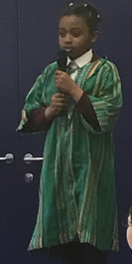
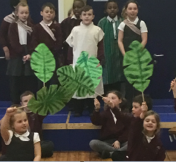
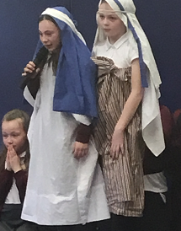

Bring and Buy Sale update
Thank you to all of the children and parents who supported our Bring and Buy Sale. The money has
been counted and I am delighted to announce that the children have all helped to raise over £90 which will go towards CAFOD and the Good Shepherd Appeal. I have also been very impressed with the children who have been contributing money to the CAFOD boxes in classes from the “Give it Up” Campaign. Some of the children have been telling me about the things that they have given up to place the money that they have saved into the CAFOD boxes.

CPR Skills for Year 5 and Year 6
Unfortunately due to unforeseen circumstances the SPR skills training had to be cancelled this week for Years 5 and 6. Mrs Waide is working to re-schedule this important training for our children in the Summer term. We will keep you informed about the future date for this.

SOCK Team
A letter has been sent home from SOCK for any children wishing to order a bunch of daffodils for Mothering Sunday on Sunday 31st March. Pupils who have ordered their bunch of daffodils will receive these next Friday to take home in time for Mothering Sunday.

Reception Class Trip
Our children in Reception had a fabulous action packed day at the Rainbow Factory. They spent the day being pirates and learning all about treasure maps, how to be a great pirate and doing lots of role play activities. The trip has clearly very much inspired the children and the writing that they have produced as a result of the trip has been fantastic!

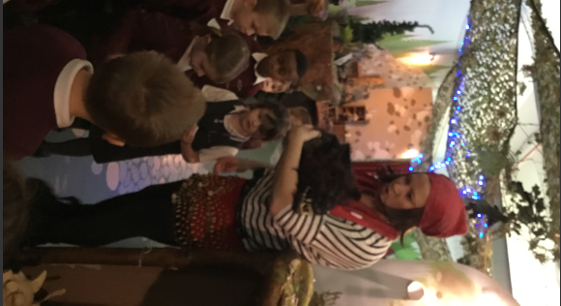
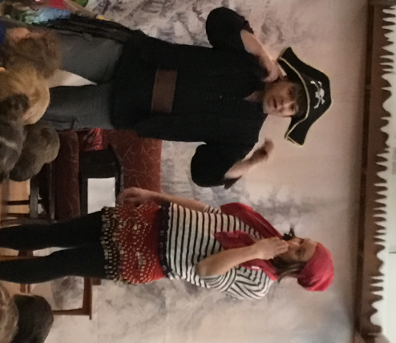

School Uniform Reminder
Please can all uniform be labelled clearly with your child’s name. This week we placed a full box of clothing outside for parents to look at. I couldn’t quite believe how many items of clothing were in the lost property box with no names! It is essential that you check your child’s clothing every night to make sure that they have brought everything home. If there are items missing I urge you to get your child to check the lost property box to find these.

I have also noticed some very elaborate hair accessories being worn in school. I would like to remind all parents that children should be wearing plain hairbands, small bows, ribbons, clips and bobbles either in burgundy or yellow in line with the school colours. This is outlined in the school prospectus which can be found on the school website under “key information”.

Easter Egg Raffle
Next week and the week following the holidays, children will have the opportunity to buy raffle tickets for an Easter egg raffle. The staff in school have generously donated several Easter eggs in preparation for this and all money raised will go towards our chosen charities – CAFOD and the Good Shepherd Appeal. Tickets will cost 20p and the draw will take place on Thursday 18th April. There are already several Easter eggs stacking up in the staff room in preparation for the raffle so there are plenty of opportunities to win an Easter egg whilst donating to a great cause!

Miss Clark
(Headteacher)

