Weekly Newsletter for week beginning 11th March 2019
Statement to live by for next week: I try to keep going when things are difficult and not give up hope.

Attendance and House Team Winners
Year Group | Percentage Attendance
Year R | 95.7
Year 1 | 96.9
Year 2 | 94.6
Year 3 | 95.2
Year 4 | 98.0
Year 5 | 96.3
Year 6 | 96.5
95.5%
The highest attendance this week was 98% in Year 5.
Our house team with the highest points so far and
the winners for this week are members from Red
team.

Bring and Buy Sale
Thank you to all of the children and parents who
supported our Bring and Buy Sale today. The Mini
Vinnies and our Year 5 pupils who suggested this
Fundraising event did a fabulous job of organising and pricing the items for sale. We are waiting on our final count for how much money has been raised from our Mini Vinnies.
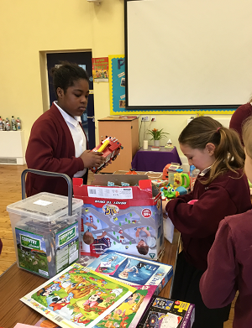
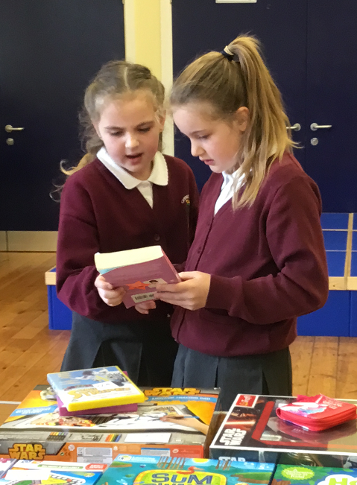

A reminder that next Thursday at 9:15am, Year 2 will be treating us with their class assembly to showcase all of the things that they have been learning about. Parents are welcome to join us as always. I know that all of our children love to see a friendly face in the audience.

Year 3 and 4 Production
A letter has been sent out to parents for tickets to the Year 3 and Year 4 production next week. Please ensure that you send back the reply slip for tickets. I know that this will be an excellent show from the sneak previews I have had whilst the children have been practising.

Christ the King Curriculum
For any parents who missed out meeting about making our curriculum bespoke to our children at Christ the King Catholic Primary School, please do get in contact with us to let us know your views. You can do this via the school email address on office@ctkcps.org.uk. Let us know your views and thoughts about what you feel is important for your child’s education. What skills you want them to learn? What knowledge you like your child to acquire? What provision would you like to see in school?

P.E. Kits and School Uniform
We still have a significant number of pupils without the correct P.E. kits in school. All children need a tee-shirt in their team colour and black shorts. In addition to this children must have an outdoor kit of plain dark tracksuit bottoms, a plain dark jumper and trainers. Children must have trainers for P.E. these can just be basic trainers and do not need to be expensive brands.

I would like to remind parents also that as per the school uniform code, pupils should be wearing black school shoes to school and have a pair of pumps in school for indoor shoes. Hair accessories should be in the school colours and not excessive in size. It is good to see many of our children with long hair tying their hair back. This is always something which we strongly advise in school.

CPR Skills for Year 5 and Year 6
Next Tuesday our Year 5 and Year 6 children will be taking part in some training by Dr. Hema from Leeds General Infirmary to learn basic CPR skills. This is an important life skill to learn for all of our children. I am sure that you will encourage the children at home and talk and share with you all of the things that they have learnt.

Reception Class Trip
A Reminder that Year R will be going on a trip to the Rainbow Factory next Wednesday 20th March. The children will be taking part in lots of creative activities and workshops focused around their learning and inspiring writing. I know that they are all very excited and Miss Riggs has lots of activities planned for when they return to school from this inspiring trip.

Sporting Successes
Well done to all of our Year 4 children who took part in an orienteering event competing against pupils within the local area. The children all did brilliantly especially as this was the first time that they had participated in an event like this.

Thank you also to all of our parents who helped us to purchase (with their donations alongside our school fund contribution) some new netball posts for our netball club members. Mr Davey has been busy assembling them this week and the netball team very much very much enjoyed using these for the first time this week in their training session.

Celebration Assembly
Advanced notice: Next week Celebration assembly will be on Thursday at 2:30pm instead of Friday.

Miss Clark
(Headteacher)
Dates for your Diary
19.03.19 – Dr Hema from LGI to teach CPR skills to pupils in Year 5 and Year 6
19.03.19 – 2:00pm Year 3 and Year 4 Easter Production
20.03.19 – 9:15am Year 3 and Year 4 Easter Production
20.03.19 – Year R class trip

