Weekly Newsletter for week beginning 4th March 2019
Statement to live by for next week: I can learn from my mistakes and failures.

Attendance and House Team Winners
Year Group | Percentage Attendance
Year R | 98.3
Year 1 | 97.4
Year 2 | 97.6
Year 3 | 95.4
Year 4 | 94.3
Year 5 | 96.7
Year 6 | 98.3
95.5%
The highest attendance this week was 98.3% in
Year R and Year 6.
Our house team winners for this week are members
from Red team.

Our Journey through Lent
This Wednesday marked the start of Lent and we
celebrated mass at Christ the King Church.
As you are aware from the newsletter last week,
we are going to be raising money to support CAFOD, The Good Shepherd Appeal and other local charities. Two of our Year 5 pupils came to ask me if we could organise a “bring and buy sale” to raise money during Lent. We thought that this was a wonderful idea. Mrs Clancy-Taylor and Miss Gray are going to help our Year 5 pupils and the Mini Vinnies to prepare this next Friday 15th March.
We would therefore ask that the children bring into school any toys in good condition that they no longer want by Wednesday 13th March. It’s a great opportunity for an early Spring clean!
On Friday the children from all classes will have the opportunity to come into the hall to buy any toys that they would like from the stalls and in the process help to raise money for our worthy charities.
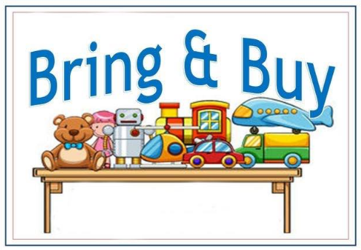
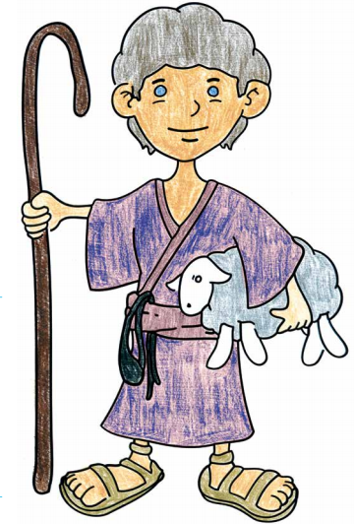
The Good Shepherd Appeal
Mrs Clancy-Taylor
and Miss Gray have said that
all items brought into school
will be priced between 20p
and £2.00.
Any items left will be
donated to St. Gemma’s
hospice which is the charity
that the parish is supporting
this year.

Year 2 Class Assembly
A reminder that next Thursday at 9:15am, Year 2 will be treating us with their class assembly to showcase all of the things that they have been learning about. Parents are welcome to join us as always. I know that all of our children love to see a friendly face in the audience.

Year 3 and 4 Production
Year 3 and 4 have been working hard on their production and are looking forward to showcasing their talents in two weeks time. A letter about tickets will be going out to parents and carers shortly.

World Book Day
Yesterday we celebrated World Book Day in School. Our Key Stage 2 children paired up with our Key Stage 1 children to share a story with each other. It was so lovely to see all of our children so enthusiastic about reading and enjoying their books with one another. We have had some fabulous entries for our competition to design a book cover and I know that the staff found it very difficult to pick the winning designs. Well done to everyone for their superb entries!
Also I know that Mrs Waide has said how impressed she was by the writing that the children in Year 6 had produced for their homework about their favourite authors. Also lots of other classes in school have completed some fabulous book reviews to share with others. The reviews and research pieces are truly inspiring and show the love that our children in school have for books.

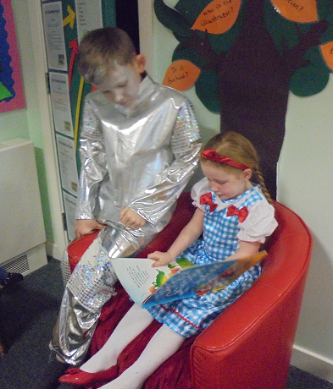
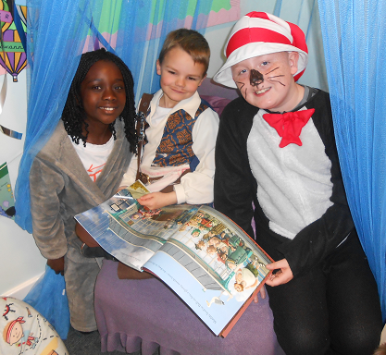

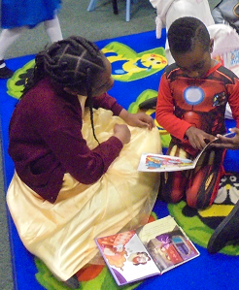

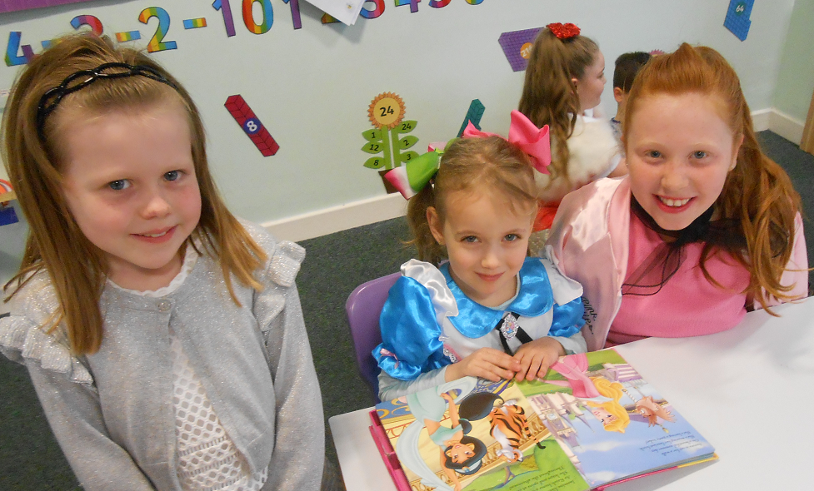

To continue this love of reading please do remember that there are a wealth of books out there and these can be accessed for free with a local visit to the Bramley or Armley library. In addition to this, if you have any books that are in good condition that your children no longer need and you would like to donate these to school, we are always looking for books to increase our library stocks across school. Any donations of books are always gratefully received.

Fairtrade Fortnight
This week Year 6 have been learning all about Fairtrade. For two weeks each year, thousands of individuals, companies and groups across the UK come together to celebrate the people who grow our food, people who live in the poorest countries in the world and who are often exploited and badly paid. Following on from their recent trip to the York chocolate factory, children in year 6 have been focusing in particular on the farmers who grow the cocoa for the chocolate that we all love to eat. Our Year 6 children have been buying Fairtrade products to help contribute to a fairer world and using these to make some delicious recipes. This week they have made some delicious Banoffee pies with fair trade products.

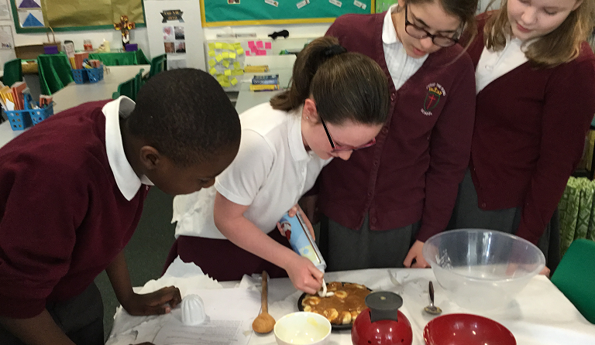
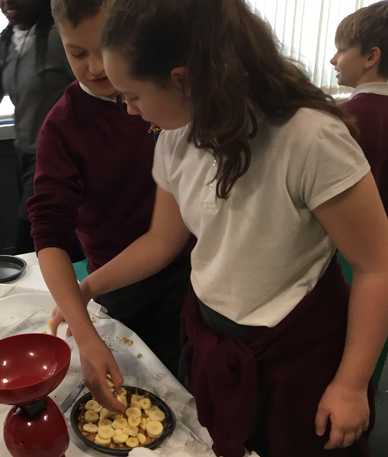

Christ the King Curriculum
OFSTED have recently carried out research and
are encouraging schools to develop their curriculum
further to ensure that it meets the specific needs of
the pupils in each individual school. As you will be
aware we work hard to ensure that all of our pupils have excellent foundation skills in the core subject areas of Maths and English and that we provide the children with opportunities to develop their skills, knowledge and understanding across all of the other curriculum subject areas such as science, humanities, P.E. etc. as well.

In school we are reviewing our curriculum to further improve it and make it bespoke to our children at Christ the King Catholic Primary School. We would very much welcome your views and thoughts as the primary educators of your children. We would like to find out what you feel is important for your child’s education. What skills do you want them to learn? What knowledge would you like your child to acquire? What provision would you like to see in school?

Please do come along for a cup of tea or coffee and a biscuit next Thursday 14th at 2:45pm to tell us what you think. All parents are welcome. If you are unable to attend but would like to share your views, please do get in touch with us via the school email address on office@ctkcps.org.uk to share your thoughts.

Miss Clark
(Headteacher)
Dates for your Diary
06.03.19 – 9:15am – Ash Wednesday Mass at Christ the King
07.03.19 – World Book Day
14.03.19 – Year 2 Class assembly
19.03.19 – Dr Hema from LGI to teach CPR skills to pupils in Year 5 and Year 6
19.03.19 – 2:00pm Year 3 and Year 4 Easter Production
20.03.19 – 9:15am Year 3 and Year 4 Easter Production

