Weekly Newsletter for week beginning 19th March 2018
Statement to Live by for next week: I know what humility means.

House Points and Attendance Attendance
Congratulations to Yellow Team who are in the lead with
Year Group | Percentage Attendance
Year R | 92.4%
Year 1 | 91.7%
Year 2 | 85.7%
Year 3 | 98.9%
Year 4 | 100%
Year 5 | 96.2%
Year 6 | 94.6%

house points this week and to Year 4 who won the
attendance trophy this week with 100% attendance.

Year 3 and Year 4’s Amazing Production
Well done to all of the Year 3 and 4 pupils and teachers for
their amazing production this week. We have some superb
actors, actresses and singers. I was amazed by the
confidence of our soloists who were pitch perfect. I am
sure you would all agree that the performance was worthy
of the West End. We certainly have some future stars!

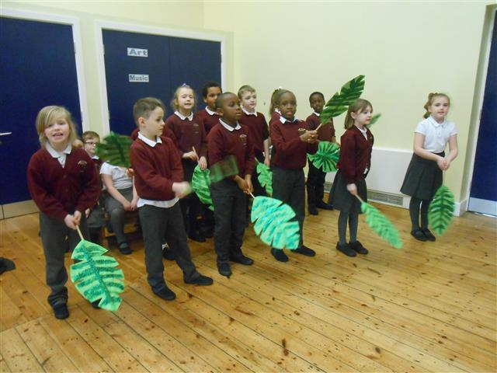
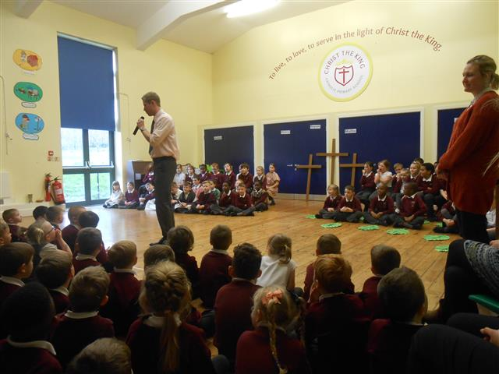

Holy Week
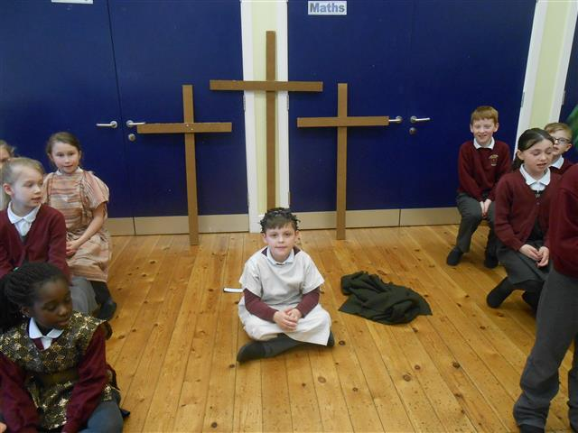
As you will be aware, next week we enter a very special time in
the church calendar as we celebrate Holy Week.
This week before mass, Fr. Paul talked to us about the story of the
Jesus’s death and resurrection as we went around the stations of
the cross in church.
Next week we will be learning about all of the events that led up
to the death and resurrection of Jesus during our lessons and
assemblies in school.

Fundraising for CAFOD and the Good Shepherd Appeal
As you know, we have been busy carrying out our fundraising events in the past few weeks to raise money for those less fortunate than ourselves during the period of Lent. If you still have your smarties tubes to return with your coins in or would like to take part in the Easter Raffle, there is still time! We will be drawing the raffle for the Easter eggs on Thursday of next week. There will be no celebration assembly, however parents are welcome to join us to see the draw for the Easter Egg Raffle. This will take place at 2:30pm on Thursday. The smarties will be shared out between the children in classes after Easter when all of the smarties tubes have been returned.

KS1 SATS and Year 1 Phonics Meeting
A letter will be going out shortly to parents in Year 1 and Year 2 to invite you to a meeting to find out more about the National Tests that your child will be sitting in May or June. I would strongly recommend that all parents attend these meetings. They will give you all of the information that you will require regarding what the National tests will look like for your child and how you can support them prior to and during these periods. Although these are statutory tests set by the government, we do not want our children to be worried about them. The teaching staff work very hard to ensure that the children feel ready and happy when completing these assessments.

